Given a 2D integer array nums, return *all elements of* nums *in diagonal order as shown in the below images*.

**Example 1:**

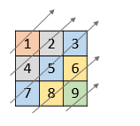

Input: nums = [[1,2,3],[4,5,6],[7,8,9]]  
Output: [1,4,2,7,5,3,8,6,9]

**Example 2:**

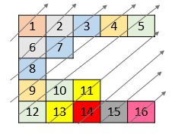

Input: nums = [[1,2,3,4,5],[6,7],[8],[9,10,11],[12,13,14,15,16]]  
Output: [1,6,2,8,7,3,9,4,12,10,5,13,11,14,15,16]

**Constraints:**

* 1 <= nums.length <= 105
* 1 <= nums[i].length <= 105
* 1 <= sum(nums[i].length) <= 105
* 1 <= nums[i][j] <= 105